Electro Magnetic Fields - Shielded EMF Protection

EMF's - Electro Magnetic Fields  All electrical appliances produce electromagnetic fields which are damaging to our health. Typical electric appliances run at 50-60hz which is significantly higher than the earth's and our bodies magnetic fields which range between 7-10hz. When EMFs come within proximity to our bodies, they cause damage to the cells by disturbing their magnetic field. The stronger the magnetic field and the higher the frequency the more damage will occur. Higher frequency waves start occurring in Cell phone transmissions, radio waves, microwaves, wi-fi and other similar devices like smart meters which are much more dangerous than regular electronics.  Measuring EMFs  We can measure EMFs in units called gauss, studies have shown that anything above 3 milli gauss will start to have negative physiological effects on the human body. Also the gauss readings get exponentially higher the closer you get. For example if you have a reading of 4 milli gauss at 2 feet away you will have a reading of 16 milli gauss at 1 foot away and a reading of 256 milli gauss at 6 inches away. Below we have prepared a table of common household items and rated them on a scale of 1-5 on how powerful and dangerous the electromagnetic field the device creates. Since at 3 mill gauss damage starts to occur on our body, we grouped the devices by how close you have to be to have 3 milli gauss or higher exposure. Remember that Shielded transmutes the EMFs to a harmless form and does not stop then so you will still get a reading on your gauss meter as the gauss meter measures the intensity of the EMF and not the frequency. |  | 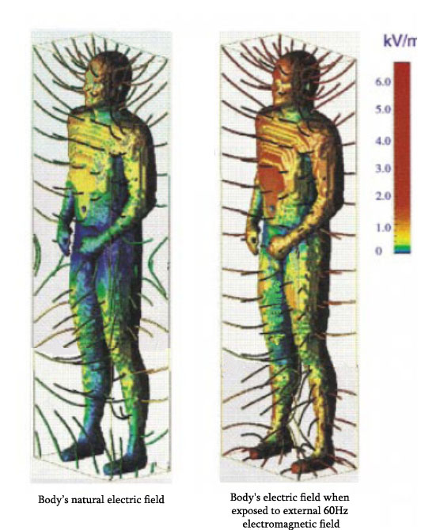  When the body is exposed to EMFs like in the picture above the electrical field of the body is disrupted causing our cells to function incorrectly.

Group 5 (worst) 3 + feet | Group4 - 1-3 feet | Group 3 - up to 1 foot | Group 2 - a few inches | Group 1 - direct contact
Microwave ovens  Wi-fi  Microwave towers  Smart hydro meters  Electric Water Ionizer  airplanes  sub-woofer | Fridge  Wireless routers  Electric blankets  Cell phones  Other Electric water ionizer  Laptop computers  Cordless phone  Clothes dryers  Television  circuit breakers  florescent lights. | Stove  Baby monitors  Electric clock radios  Desktop computers  LCD or LED Tvs  Electric heaters  Hot water tanks  Kettles  Other corded electric appliances | Toaster oven  Other hand held electric appliances  small battery operated devices  computer screen | Electric outlets - not plugged in  Battery operated watch  headphones  computer mice and keyboards

How do EMFs impact our body.
The first thing to understand is our bodies have their own magnetic fields. Our bodies conduct electricity through neurons and muscles, sending
small electrical impulses to the brain, the heart also generates these electric signals to keep it beating. New studies are even showing that each
individual cell has its own magnetic field which builds up on our entire framework. When we measure a healthy body, we will find the magnetic
field has a frequency of about 7-10hz. What is interesting is when the earth's magnetic field was measured in the 1950s it frequency was recorded
at 7.83hz and has been changing slightly over time. You can see that our bodies and the earth's magnetic field operate at the same frequency along
with all other living things on this earth.

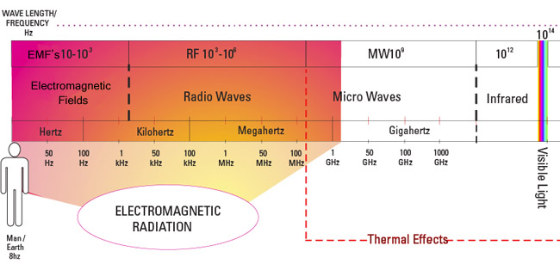

In North America all electronics operate at 60hz and in Europe they operate at 50hz. These frequencies are severely incompatible with our bodies so when we enter their magnetic fields, they disrupt our own. Our own bodies magnetic field is at a very low level and therefore can be disrupted relatively easily. Studies have shown when we come in contact with stronger EMFs, they disrupt each of our bodies cells magnetic fields and increase the bodies voltage. When your cells magnetic fields are altered by strong EMFs they cannot function correctly. This is similar to trying to use a TV designed for European outlet being used in a North American outlet, since the circuits are not designed to run at the same power or frequency ( 50hz compared to 60z) the TV will eventually overheat and burn out. This is the same case with our cells, they are designed to operate with a magnetic field of 7-10hz but when influenced by EMFs their magnetic frequency rises and they start operating at a frequency they are not capable of handling. This can cause immediate symptoms in some people of pain, burning skin, headaches, blurred vision, and making your skin crawl. If it is just a short period of time the body will re-balance its magnetic field and start functioning correctly. The problem occurs with too much exposure or at too high a level of EMFs where the cells get so disrupted, they cannot re-balance their magnetic field and continue functioning incorrectly. This is when serious and chronic conditions and disease can start occurring in the body. We are now seeing cancer and tumors being linked to EMF exposure as both these disease are the cause of cells growing incorrectly and uncontrollably.

